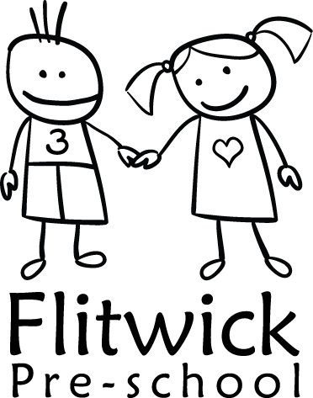
FLITWICK PRE-SCHOOL
01 Health and safety procedures
No smoking

- We comply with health and safety regulations and the Safeguarding and Welfare Requirements of the Early Years Foundation Stage in making our setting a no-smoking environment - both indoors and outdoors.
- All staff, parents and volunteers are made aware of our No-smoking Policy.
- No-smoking signs are displayed prominently.
- The No-smoking Policy is stated in information for parents and staff.
- We actively encourage no-smoking by having information for parents and staff about where to get help to stop smoking if they are seeking this information.
- Staff who smoke do not do so during working hours, unless on a scheduled break and off the premises.
- Staff who smoke during working hours and travelling to and from work must not do so whilst wearing a setting uniform, or must at least cover the uniform.
- E-cigarettes are not permitted to be used on the premises.
- Staff who smoke or use e-cigarettes during their scheduled breaks must be well away from the premises (outside of the main garden/gate).
- Staff who smoke or use e-cigarettes during their break make every effort to reduce the effect of odour and lingering effects of passive smoking for children and colleagues.
- Staff are made aware that failure to adhere to this policy and procedures may result in disciplinary action.
- It is a criminal offence for employees to smoke in smoke-free areas, with a fixed penalty of £50 or prosecution and a fine of up to £200.

Legal framework
- The Smoke-free (Premises and Enforcement) Regulations (2006)
- The Smoke-free (Signs) Regulations (2012)

This policy was adopted at a meeting of Flitwick Pre-school on ____________________________

Next date to be reviewed February 2023

Signed on behalf of the management committee ________________________________

Name of signatory ____Ritu Mistry_______________________

Role of signatory (e.g. chair/owner) _____Chairperson_______________

