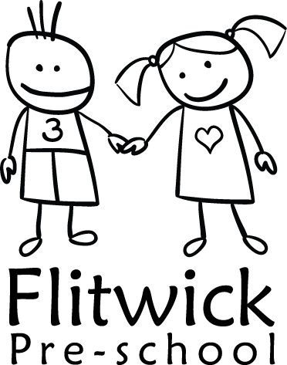
FLITWICK PRE-SCHOOL
01 Health and safety procedures
01.16 Festivals (and other) decorations

General
- Basic safety precautions apply equally to decorations put up for any festival as well as to general decorations in the setting. Children are informed of dangers and safe behaviour, relative to their level of understanding.

Decorations
- Only fire-retardant decorations and fire-retardant artificial Christmas trees are used.
- Paper decorations, other than mounted pictures, are not permitted in the public areas of the buildings, for example, lobbies etc.

Electrical equipment.
- Electrical equipment (a light, extension leads etc) must be electrically tested before use.
- If using tree lights, place the tree close to an electrical socket and avoid using extension leads. Always fully uncoil any wound extension lead to avoid overheating.
- Remember to unplug the lights at the end of the day.
- Electrical leads are arranged in such a way that they do not create a trip hazard.

Location
- Trees and decorations must never obstruct walkways or fire exits.
- Do not place decorations on or close to electrical equipment (e.g. computers); they are a fire hazard.
- Decorations must be clear of the ceiling fire detectors, sprinklers, and lights.

Children’s areas
- Christmas trees are placed where children cannot pull them over.
- Glass decorations are not used.

These procedures were adopted at a meeting of Flitwick Pre-school on _____________________

Next date to be reviewed November 2022

Signed on behalf of the management committee ________________________________

Name of signatory ___Ritu Mistry______________________________

Role of signatory (e.g. chair/owner) ___Chairperson______________________

